Edward de Bono’s Six Thinking Hats:

Edward de Bono is recognized as one of the most influential thinkers in this century. His theory of lateral thinking is one of the phenominal works in the field of thinking process and creativity. His theory of “Six Thinking Hats” shows how each of us become a better thinker through deliberate role playing with the help of real life examples.
Often, the best decisions come from changing the way that you think about problems, and examining them from different viewpoints.
"Six Thinking Hats" can help you to look at problems from different perspectives, but one at a time, to avoid confusion from too many angles crowding your thinking.
It's also a powerful decision-checking technique in group situations, as everyone explores the situation from each perspective at the same time.

Dr.de Bono invented the six thinking hats method early in the 1980s. The method is basically a framework of thinking.

The Six Hats represents Six models of thinking and are directions to think rather than labels for thinking. That is the hats are used proactively rather than reactively. The method promotes fuller input from more people. In de Bono’s words it separates “ego from performance”. Everyone is able to contribute to the exploration of a problem without denting egos as they have an excuse of using a particular hat. The six hats system encourages performance rather than ego defense. Valuable judgmental thinking has its place in the system, but is not allowed to dominate as in normal thinking. People can contribute under any Hat even though they initially support the opposite view.
The key theoretical reasons to use the Six Thinking Hats are to;
- Encourage full spectrum thinking
- Separate ego from performance.

There are six metaphorical Hats and the thinker can put on or take off one of these hats to indicate the type of thinking being used. This putting on and taking off is essential. The hats must never, be used to categorize individuals, even though their behavior may seem to invite this.
The Six Thinking Hats:
- White Hat Thinking (neutral and objective)
with this thinking hat, you focus on the available data. Look at the information that you have, analyze past trends, and see what you can learn from it. Look for gaps in your knowledge, and try to either fill them or take account of them.

- Red Hat Thinking (Powerful emotions)
This covers intuition, feeling and emotions. The red hat allows the thinker to put forward an intuition without any need to justify it. Usually feelings and intuition can only be introduced into a discussion if they are supported by logic. Usually the feeling is genuine, but the logic is spurious. The red hat gives full permission to a thinker to put forward his or her feelings on the subject at the moment.

- Black HatThinking (negative or critical)
This is hat of judgment and caution. using Black Hat thinking, look at a decision's potentially negative outcomes. Look at it cautiously and defensively. Try to see why it might not work. This is important because it highlights the weak points in a plan. It allows you to eliminate them, alter them, or prepare contingency plans to counter them.
Black Hat thinking helps to make your plans "tougher" and more resilient. It can also help you to spot fatal flaws and risks before you embark on a course of action.
- Yellow Hat Thinking (positive and optimistic)
- This is the logical positive. This hat helps you to think positively. It is the optimistic viewpoint that helps you to see all the benefits of the decision and the value in it. Yellow Hat thinking helps you to keep going when everything looks gloomy and difficult.

5.Green Hat Thinking (Creative)
This is the hat of creativity, alternatives, proposals, what is interesting, new ideas and changes lateral thinking (thinking out of box) could be used here. This is where you develop creative solutions to a problem. It is a freewheeling way of thinking, in which there is little criticism of ideas

- Blue Hat Thinking (in control)
This is the overview or process control hat. It looks not at the subject itself but at the ‘thinking’ about the subject. Putting on a blue hat some more green hat thinking at this point should be done.

It is absurdly strange what a colored hat can do to a person’s mind. It is funny to see a totally negative person to open up when he is put to challenge his own thoughts.

In general this is a very useful model for facilitating meetings, brain stormings or conflicts resolving sessions. Also the author (de Bono) claims that the method reduces time spent in the meetings by 20 – 90%.

The Six Hats Method:
Thinking is the ultimate human resource. Usually, the only people who are very satisfied with their thinking skill are those poor thinkers who believe that the purpose of thinking is to prove yourself right to your own satisfaction.

How to Use the Six Thinking Hats
Now that you have a solid understanding of the Six Thinking Hats. it’s time to briefly point out how these hats work together to help you formulate effective solutions and new ideas.
The process begins when the managerial blue hat (Director) allocates thinking time to each of the six hats, including itself. Often the order of thinking would progress in the following way:
- The blue hat defines and outlines the problem under question. It then guides the other thinking hats through the thinking process.
- The white hat collects all the facts, data, and statistics related to the problem. It then uses this information to settle on several logical solutions to the problem.
- The red hat intuitively reflects on the solutions. Then, based on its hunches, it selects the best course of action moving forward.
- The black hat quickly pinpointing holes, dangers, flaws, and limitations of the proposed plans.
- The yellow hat now challenges the black hat’s pessimism by bringing to light logical ideas and contingency plans that help circumnavigate these dangers.
- The green hat then takes these ideas and enhances them using its out-of-the-box thinking mentality.
- After all the thinking hats have had their say, the blue hat continues to transition between the hats in a logical order. It may, for instance, ask the red hat for its intuitive insights about the green hat’s ideas. Or, it may ask the white hat to gather more facts and information about the dangers that the black hat brought to light. After which, it may ask the yellow hat to bring forth some logical solutions to the problem at hand.
without aimless drifting. In the next section, I will begin to talk specifically about teaching and using the six hats.

Teaching The Hats:
The learning and practicing must be enjoyable.
Sessions introducing the hats should move briskly and discussion should be as practical as possible. As each hat is taught, give repeated clear examples of its uses. Matters will arise which can be confusing. For example, many ideas may fit under two hats at the same time. There needn’t be any problem with this-just identify how you are deciding to accept and make use of the comment.
Student: That’s not green hat, that’s yellow!
Teacher: Perhaps it’s both. Because it’s stating something good about the situation
but Also offers a new suggestion. Let’s include it on our list under the green hat because we’re trying to think of new ideas at the moment.
If the comment is clearly off target, settle the matter quickly and move on.
Student: I think that’s a good plan.
Teacher:Your comment is okay for red hat thinking, but we’re using the yellow hat
right now. What are thegood points about the plan? Why do you think it’s good?

1.15.12 Steps in the Lessons:
The actual steps provided in this book for teaching the hats are as follows:
- Lead-In. Begin with a simple illustrations, example, or exercises that shows in action the process that is to be taught.
- Explanation. Move at once to explaining what is to be taught-the nature of the selected hat. With eight – to ten-year-olds, this explanation can be rather brief.
- Demonstration. Give more examples demonstrating the process in use. Invite discussion, suggestions, questions, etc.,
- Practice. This is the most important part of the teaching. The students them selves use the process on practice items. Offer an many practice items as possible. Do not spend a long time on any one item, as this distracts attention from the process. Remember that the purpose is to teach a skill, not to have an interesting discussion. If one item does not work well, move right on to another item.
- Elaboration. In practicing the process, you and your students may be able to make additional observations on how the process is used. These may arise from the way a particular practice item has been tackled or in answer to questions the students ask. After students have been introduced to each hat, invite them to be alert to times when they are able to use the hat in real life. These observations can be noted in a journal and shared in subsequent class discussions.
- Conclusion. Summarize the process, repeat the main points and emphasize why the process can be useful.

1.15.13 An example of Six Thinking Hat lesson that can take place in the classroom
6 Thinking Hats Example
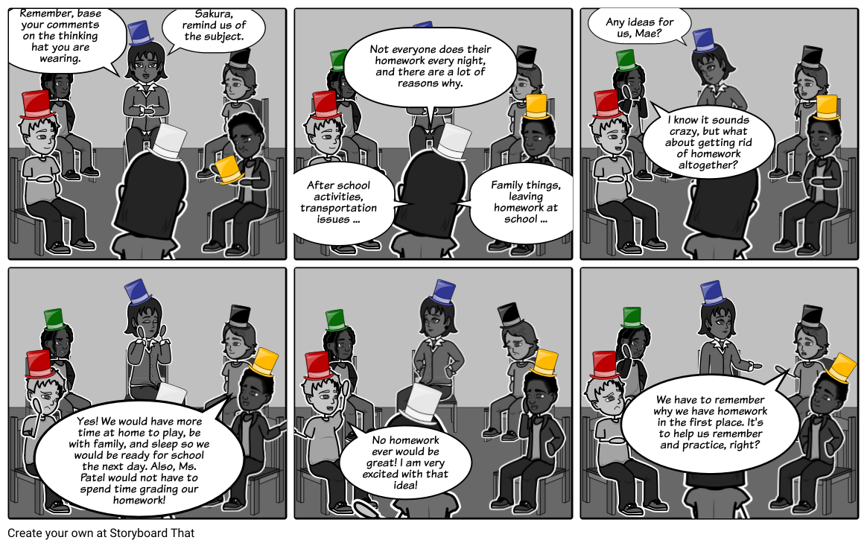
Thus ,it can be concluded that six thinking hats serve the following purpose:Decisions seem to make themselves ,„ Focused thinking ,„ Improved exploration ,„ Improved creativity & innovation ,„ Foster collaborative thinking ,„ Provides a common language, „ Helps people work against type, preference ,„ Removal of ego from decisions (reduce confrontation) ,„ Allows a switch in thinking without threatening ego and Saves time

